Approaching the End of an Era
A look at Unionville as it was between 1871 and 1887

Researched and authored by:
Mrs. William (Ruth) Taylor
Unionville PA 19375
(circa. 1975)

Forward
In order to get this written and typed up in time to enclose in the Christmas presents, some of which have to be mailed, there was no time to produce a finished piece of writing. As a result, I, no doubt, am being ‘FORWARD’ to inflict this rough state upon you. (who said that a pun was the lowest form of humor?)

Approaching the End of an Era
A look at Unionville as it was between 1871 and 1887
During its early days, there was little growth reported in Unionville. About 1800 the village started to expand, and by 1825 businesses began to develop. It experienced its greatest growth from 1843 to 1851. At the time this map [sic, presumably the 1874 and/or 1883 maps of East Marlborough Township and Unionville, see Editor Notes] was published, Unionville was not only almost a self-sufficient town, but was considered a metropolis for the surrounding townships. This was due mainly to the varied social life and activities of the town. These were duly reported in The Daily Local News. The majority of the following information has been taken from this source.
There were activities for all. For the intellectuals, there was there were lyceum and lecture courses at Unionville Hall. There also were debates and discussions, recitations and music. It cost 10 cents to get into a debate. I. Milton Smith was greatly esteemed as a reader and reciter. Edward and Thomas Seale were the leaders in progressive thought as were James Smith, Thomas Chambers, Squire Chambers, the Wilkinsons, Mrs. George Wickersham and a number of others. The Lyceum was held every 6th day evening.
Devotees of Terpsichore held a series of socials in 1879 Shirley's orchestra was frequently imported from Philadelphia [Editor’s Note: From Wikipedia, In Greek mythology, Terpsichore is one of the nine Muses and goddess of dance and chorus. She lends her name to the word ‘terpsichorean’, which means ‘of or relating to dance’] This group consisted of a violin, coronet and harp, and was greatly favored for dancing parties, which usually were held in the Hall. In 1879 there is a mention made in a news article about a Unionville Orchestra playing at a local event.
The public brick Hall had been built in 1850 and was considered the finest for miles around. In 1878 the Odd Fellows furnished their room with a large new cabinet organ and every Saturday evening the music accompanied their opening and closing odes. Not to be outdone, the trustees of the Hall where the lyceums and lectures and traveling groups performed quickly made plans to purchase an organ for the lecture room. The Presbyterian Church acquired its organ in 1885. In 1859 there had been only one piano in the village, but by 1879 there were many pianos and organs.
There is one account which describes one evenings entertainment of a slightly different nature. On October 5, 1874 when the Odd Fellows Hall needed a new grain carpet to cover the lodge room, twenty six ladies sewed while they and the gentlemen, babies, and children who accompanied them were serenaded by an organ, violin and horn performed by Professor Terry, Baldwin, and Lollar. After the carpet was finished, they had refreshments of oysters in various styles, cakes, and watermelons.
Many traveling groups came to Unionville. During one week in 1877 there were are reports of these visits. On Monday, a huntsman with stuffed animals pitched his tent and stayed two days. Soon a showman was open for business in the town hall with an exhibition of ventriloquism and necromancy. He remained two nights. The first night was free and the account states there was much hilarity and horseplay, but since the next one was a pay night the second evening's audience was much smaller and more attentive.
Beginning probably about 1874 Unionville men became seriously interested in croquet. Unionville soon became the ‘hub’ of croquet. Old and young studied the game until all scientific points had been well and truly developed. They even contemplated writing a book of revised rules. Croquet was played perpetually six days a week (Sunday excepted). It started at early dawn and continued ‘til after dark in a yard attached to Mr. Jacob Love’s refreshment saloon. To this village green were drawn half of the males to either play or watch. After dark a dozen or more flaming torches were posted about the grounds. Beause of extreme interest in the tournament of 1874 the societies ceased to hold their meetings until after croquet season was over when they could once more manage a quorum at their gatherings
In 1876 the ‘All Unionville 7’ played and vanquished Coatesville, Charlie Webb and Kirk Vandaver were considered the best players. Several years later there is an account where they are trying to decide if they should enter a competition with a champion French team that was coming to Philadelphia. I could find no account of their final decision.
Those who did not play croquet usually passed the time at target shooting. In 1874 a Unionville Rifle Team had been organized. One humorous note states that ‘they could plug a large dinner plate at five yards off’.
The churches also had their entertainments. One news account in 1883 states that a Christmas Festival was held by the Union Sabbath School last Saturday evening. It was well attended, and the children were pleased because the tree was stripped of its fruitage. Another account tells that the colored folks had a Christmas social in the hall, which included a ‘tree shake, whatever that may be’. In 1855 the Presbyterian Church held a strawberry festival on Friday and Saturday evenings in the Unionville Hall. The Unionville Orchestra played on August 23 1875. Another article describes a successful peach festival held both Friday and Saturday evenings at which the orchestra played and $106.00 was raised for the benefit of the church. In the 1870s there is mention made of a Martha Washington Tea Party being held to pay the Presbyterian Church minister’s salary.
A tavern, hotel and stores drew the gathering of gossips and storytellers. There were two stories in Unionville. Apparently, the store run by Milton Smith had a front porch at this time. There are several articles complaining about the gatherings there. As early as 1871 there is one that says that the bar room of the hotel was an orderly place in comparison to the porch of the store which owners and law alike tolerated. Another complained about the language used there. As late as 1884 people were still complaining. One account tells of Mr. Smith laying a brick pavement but suggests he would do better to try to ‘prevent colored gentlemen from using it for guerilla war and dancing’. Another angry citizen complained about the ten to twenty men who sit or stand on the porch and wish they would leave an open aisle to get in and out of the store.
Although Unionville never acquired a jail, in 1885 there was talk of having a lock up built in Unionville in which to incarcerate disorderly characters, of whom there have been a considerable amount of late. This disorder in is not altogether caused by home talent, but by a large amount of liquor being imported, in some instances in packages from Philadelphia.
By 1887 there is no mention of the George Wickersham store, but there is a report of some importance regarding the ‘second store’ in Unionville. It tells of a James T. Galt who ‘kept’ a store in a building owned by John Henry Marshall. A telephone line was run from Unionville to West Chester and the first telephone was installed in Mr. Gault’s store with an extension to the tin-smithing shop of C. Wilson Loller. The first message was: ‘Hello, Jim, send me over a plug of Happy Thought’, spoken by Mr. Lollere, even though he did not use chewing tobacco. It was surmised that in the excitement of the moment, desperately searching for a happy thought to say he struck upon this. Crowds assembled at each call as the townspeople considered a telephone a ‘marvel of most magical qualities’.
And of course, there were parties and social events held in private homes
Anxious to keep up with the newer developments, a boardwalk mania raged during 1878. Although they were considered temporary pavement, sidewalks of oak, hemlock and native timber were built. From the trunk line one ran between beyond the Presbyterian Church. Another ran North on the Embreville Road to Squire Chambers’ residence (1/4 mile from Main Street). A newspaper correspondent predicted that ‘future pavement may be Nicolson, locust block, asphaltum, concrete, or Belgian’ (block).
[Editor Note: From Wikipedia, ‘Nicolson pavement, alternatively spelled "Nicholson" and denominated wooden block pavement and wood block pavement, is a road surface material consisting of wooden blocks. Samuel Nicolson invented it in the mid-19th century. Wooden block pavement has since become unfavored because of its poor surface quality and high cost of maintenance.]
in 1885 Unionville purchased a number of old lamp posts from the Westchester Gas Company. They were put into position, oil lamps placed in them and lighted for the first time in November of that year.
Most of the town's people had good horses for transportation. Many of the residents prided themselves upon the fine appearance of their sleek trotters or pacers, and the carriages that took them to Kennet or Westchester were the latest word in neatness and polish.
Perhaps some of the more thoughtful men of the village were becoming concerned about the future of Unionville. The population and growth of the town had been more or less leveled off for the past twenty-five years. The population averaged about 400 people made up of 75 to 80 families representing about 350 residents and the rest derived from the pupils at the boarding school and the temporary boarders at the hotel. Although there had been occasional engineering surveys for a railroad, one even coming through the town, when the Philadelphia and Chester County R.R. was built about 1875, it ran several miles north of town. Many subscribers to the newspaper had written letters wishing that the railroad would have been constructed and that it would have reached their village.
During the 1850s and 60s Unionville was perhaps the most extensive cattle market in Chester County. Stock was driven there from Ohio, Illinois, Virginia and localities of greater distance. In 1879 Mr. John H. Gray opened a new stand at Unionville where he held monthly sales. One gentleman recalled having seen 75 dealers seated at the dinner table in the hotel. However, by 1891 this same man declared that ‘cattle feeding in this country is almost a thing of the past’.
The academy at the western end of town (built in 1834 and the boarding house in 1837) for which for many years had enjoyed an excellent reputation and was justly proud of the many than famous alumni. Of the many then famous alumni, such as Bayard Taylor and the mayor of Mobile, Alabama had only 10 years left as a boarding institution for both sexes. By 1893 it would be purchased by the township for a public school to replace the two room stone schoolhouse built in 1850 on Quaker Hill, which would have become too small. However, during the time we are considering it was still a thriving institution.
One account states that in 1873 the school was given a winter holiday and the students piled into horse drawn sleighs, one pulled by four horses, and went for a long ride through Avondale, Kennet Square and Red Lion, probably about an eighteen mile trip. In 1876 one of the students sent to this country by the Japanese government, Sebasso Tasharo was a pupil at the academy. The school was run by Jacob W. Harvey who was to become the County Superintendent.
The post office which was established in 1804 by William Sharp, postmaster, had gravitated between the two country stores according to the politics of the party in power in Washington. As Republicans was [sic] for many years dominant, the Post Office usually was located at the Smith emporium. However, in 1885 and throughout President Cleveland's administration, because both storekeepers were Republican and they needed a democratic postmaster or the first time since 1861, the job was given to James Whitcraft. Since he was not a resident of the boro he acquired a home and the post office moved to his house.
Until the Philadelphia and Chester County R.R was built, the mail was hauled by stagecoach. After the arrival of train service, the government made yearly contracts for hauling on the mail routes. In 1885 the post office job was worth $250 (the postmaster getting paid according to the cancelations he made).
The Union Hotel, built in 1834, enjoyed a flourishing business, although it apparently was closed in 1874. It was reopened in 1876 by Benjamin F. Martin. Not only did the hotel keep borders, but it was necessary to maintain a livery stable and plenty of water for the stock as well as a large cattle drove yard. It also contained a tavern.
On February 22,1937 the daily local news published an article by Hayes C. Taylor in which he discusses the early industries of Unionville. He states that during the 1830s there were 3 restaurants, 2 stores, a public library, a wheelwright, a blacksmith, 2 doctors, an undertaker, a large tannery, a saddler, a dressmaker, a milliner and a shoemaker. I have not been able to locate all of these, but by talking to some of some ‘old timers’ they tell me that Miss Mary Gordon was had the millinery shop in her home, in a room over the side porch, Lydia Hall was the dressmaker, Jonas Webb cobbled shoes in a little shop behind his house on Baltimore Avenue, and David B. Pyle was the cabinet maker. The wheelwright and blacksmith were in great demand because of the smart rigs and horses. The tinsmith (probably would be a plumber today) C. W. Loller, was located in a building next door to the wheelright. The barn back of the house, next to the double store, was a blacksmith shop. Frank Lamborn made and mended harnesses. The two doctors were Dr. Charles Seal and Dr. Stebbins, followed by Dr William R. Perdue. Dr Seal's office was a building standing now in the yard of Ceil Thorn. It is reported that Dr Seal died of consumption.
The Union library began in 1800 and had 54 names on the subscriber list. There was to be no bank in Unionville until 1919, but James Smith drove to Westchester at least once a week, carrying the surplus cash in a small leather grip to the Nat’l Bank of Chester County, in which he was a director. In 1879 ‘Trade Dollars’ were only worth 98 cents at the bank in West Chester but in Unionville they were still taken at par, and according to one correspondent they were ‘glad to get them at that’. A Mr. W. McGuire had a tailor shop over Smith and Chambers store’ in 1876
On the 1873 map of Unionville the following men and their occupations are listed:
Andrew A. Best - Carpenter, builder, contractor
Job Hayes - Retired Farmer
Lollar, C. W. & Sons - Manufactured Iron and Tin Wear, dealer in stoves, cucumber pumps|
Love, J. & George W. - Wheelwright and Coach Makers, Blacksmiths & Prop of a Chopping Mill
Martin B. F. - Proprietor of Unionville Hotel
Pusey, Jesse - Retired farmer and merchant.
Pyle, D. B. - General, Furnishing, Undertaker
Seal, Edwin H. - Retired merchant
Smith, T. C. Esq - Retired farmer
Wilkinson, S. (J. P. & Bros) – Tanners
There was a soda fountain in Chambers & Smith's Emporium in 1873 and ice cream parlors operated by George and Jacob Love. In 1856 Thos F. Seal had started a nursery and a floral business. Some of the nursery stock may still be on Mrs. delaRigaudirer’s [sic] property.
In 1830 the tannery had been built by James P. Pugh. He was followed by his brother as proprietor (Elijah). In the residence adjoining the tannery would be born Charles E. Pugh, a prominent man connected with the Penna R.R. Railroad. The tannery was destroyed by fire on June 5, 1874. The fire was believed to have been started from a spark from a firecracker. After the fire Sam & John Wilkinson purchased the tannery and the ground on which it stood. They later built a brick building and carried on the tannery business.
The bark was stored near the malt house. The bark was ground and the liquor contained was obtained was used in the vats to cure the hides. When the tannery was in operation, the pleasant odor of tan bark floated on the breeze.
At this time, Unionville was divided into two religious camps. The Methodists, after having 25 years of difficult times, had recently sold the Harmony Hill Church on Wawaset Road to the adjoining owner, who demolished the church. In 1844 the heirs of Thomas Seal had given one acre of ground on which in 1845 the present brick meeting house had been built. Soon after these same heirs gave ground for the cemetery. Annie Seal, daughter of Dr Chas. Seal left a bequest of $2,000.00 for a sturdy iron fence to enclose it. This area became known as Quaker Hill. The meeting house was open each first day and reportedly had good attendance.
At the southern end of town, the Presbyterian Church was incorporated in 1844. For $500.00 they purchased land and built a stone building. Unable to support a regular preacher, Rev. Thomas Thompson, pastor of the DOE Run Presbyterian Church, was the stated supply (sic] at Unionville. He conducted the spiritual affairs of the church from 1875 to 1885. J. T. Alexander served as Sect. for the Trustees. There were no elders in 1881 so Miss Mary Gordon attended the Presbytery meeting and secured the Rev. R. E. Flickinger in of the Doe Run Church for services every other Sunday evening. Unionville was to equally share the cost with the Doe Run Church. Miss Gordon paid the Unionville share, but as the DOE run church did not maintain their share, this arrangement came to an end.
Mr. Robert G. Smith who ran a business in Embreeville, conducted a Union Sunday School at Green Valley. A news item in the Daily News and dated Feb. 21, 1883 states, Mr. Robert G. Smith, assisted by Edward Bodle, both of Unionville predicted that some boys and some would be young men would annoy the meeting to such an extent as to break it up, as had been done hithertofore [sic], but I am happy to say that such is not the case. Indeed, it is just the reverse. For any time, one could almost hear a pin drop. The congregation, though small at first, has increased, and now the house is pretty well filled. The enrollment in the Sunday school (a combined figure for the Unionville and Toughkenamon Schools rose from 72 members in 1881 to 235 in 1887.
Another news item states that in 1886 Reverend T. D. Elder, pastor of the Unionville Church had preached his farewell sermon.
Little else is recorded of the religious life in Unionville during this time. However, one ‘old timer’ says that J. Smith's daughter, Mame, declared that she didn't want to go to heaven if there were going to be any men there.
Such was life in Unionville from 1871 to 1887. Still to come would be its gradual decline and stagnation. Nearby towns with transportation would expand and grow, drawing the business away. The Industrial Revolution would continue to spread and develop until goods which were being produced on a small scale would no longer be practical. It would become cheaper to produce them in the larger towns.
Unionville would return to being a quiet country village.

Acknowledgements
I, the undersigned do hereby acknowledge that, as a two finger typer who did this in an awful hurry, you are indeed patient to have born with me thru the many mistakes. Sorry about that.
Mrs. William Taylor Sr. (Ruth), Unionville PA, 19375

Editor’s Notes
Documents: Several versions of this manuscript attributed to several authors, and all undated were found amongst the treasure trove of Unionville memorabilia collected by John and Patricia Montague over their lifetime and donated to East Marlborough Township in 2024.
The Unionville Presbyterian Church is a likely source of the mimeograph machine used to make a copy that identifies The Rev John Ferguson was the author; however, there is a handwritten note stating, ‘We think Joanna Bucknell wrote this paper or Mrs. Bill Taylor, I did not, JF’. The mimeograph copy was likely made no later than approximately 1980, perhaps for distribution at Unionville celebrations of the American Bicentennial (1976) or the Chester County Tricentennial (Unionville Day, 1982).
Authorship: Another copy of the manuscript identifies Mrs. William (Ruth) Taylor as researcher and author. Because the author has included her US Postal Service 5-digit zip code, the document is dated no earlier than 1963.
Source Documents: The author identifies the Daily Local News as the primary source of first-hand reports used to create the manuscript. The Daily Local News has been continuously published in West Chester, Chester County, Pa. since 1872.
The author may also have incorporated information from:
- ‘Unionville – How it is Pictured by a Fair Young Resident’, authored by Miss Jennie H. Wickersham, a member of the Unionville High School graduating class of 1896 in West Chester Local News, Friday May 22, 1896, and
- Four articles published by Johanna Bucknell a Junior at the Westtown School in 1947 in Kennett News and Advertiser, Kennett Sq, PA.
Also mentioned in the manuscript are two historic maps of East Marlborough Township from two atlases published in the latter 19th Century.
- The earliest of these is the Atlas of Chester County Pennsylvania published by A.R Whitmer, Safe Harbor, Lancaster PA in 1874. The 1874 Whitmer Atlas shows roads, rivers and streams, municipal and property boundaries, and buildings. The map of East Marlborough Township (No. 27) contains an insert showing the village of Unionville in greater detail. A unique feature of the 1874 Whitmer atlas is that it identifies the owners of specific properties and their occupations, as stated in the manuscript.
- The latter is the 1883 Breous Official Series of Farm Maps Chester County Pennsylvania published by W. H. Kirk & Co. Philadelphia. The map of East Marlborough Township (No. 201) also identifies the current property owners but without their occupations. A unique feature of the 1883 Breous atlas is a separate page (No. 122) including maps of the villages of Malvern, Hamorton, and Unionville. The differences in cartographer’s details of the Village of Unionville in 1874 and 1883 compared to previous maps published 1847 (Painter and Bowen) and 1860 (T. J. Kennedy) further support the author’s thesis that Unionville was an important hub of social, commercial, and agricultural activities in the late 19th century.
For the readers’ convenience, copies of all aforementioned maps are provided by the Editor with this reproduction of Ruth Taylor’s manuscript.
L.B. Kinter, Editor
808 Wollaston Rd. – Unionville
Kennett Sq, PA 19375
October 2025

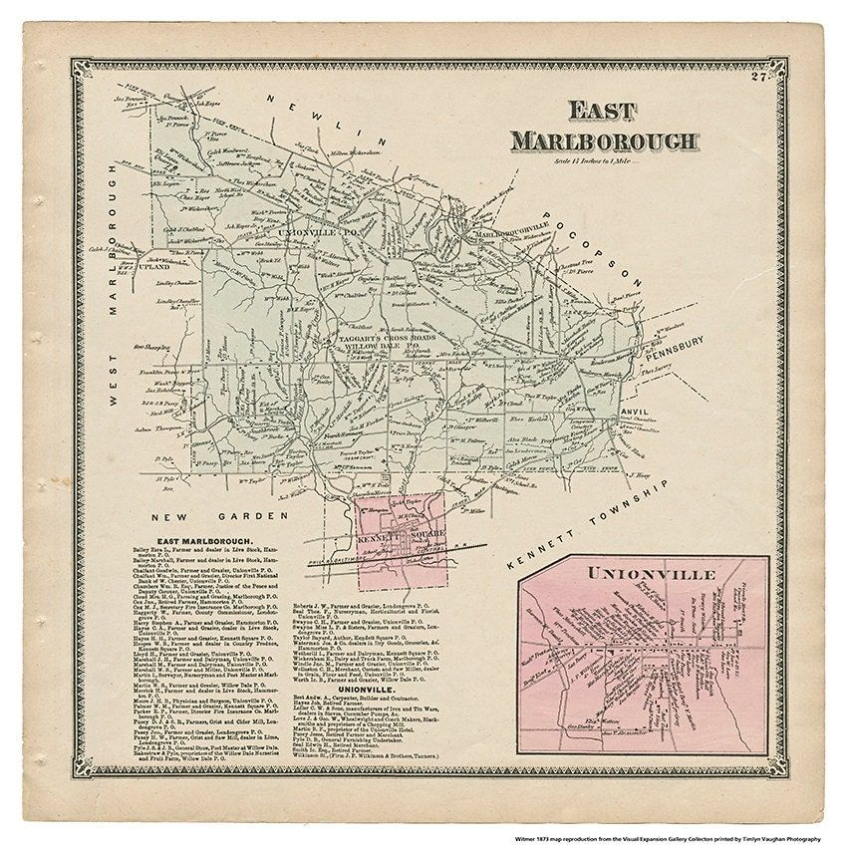
1874 Whitmer Atlas map of East Marlborough Township with separate inclusion of the Village of Unionville, Plate 27

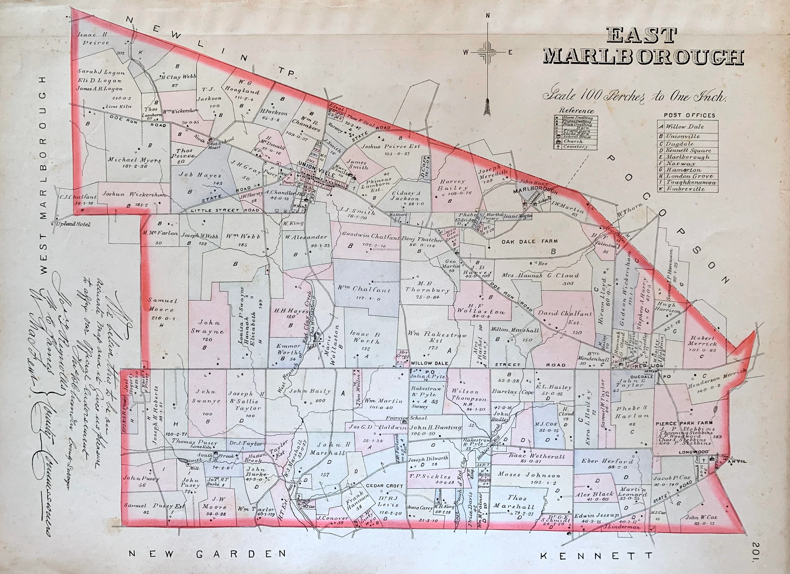
1883 Breous Official Series of Farm Maps Chester County Pennsylvania published by W. H. Kirk & Co. Philadelphia. Plate 201
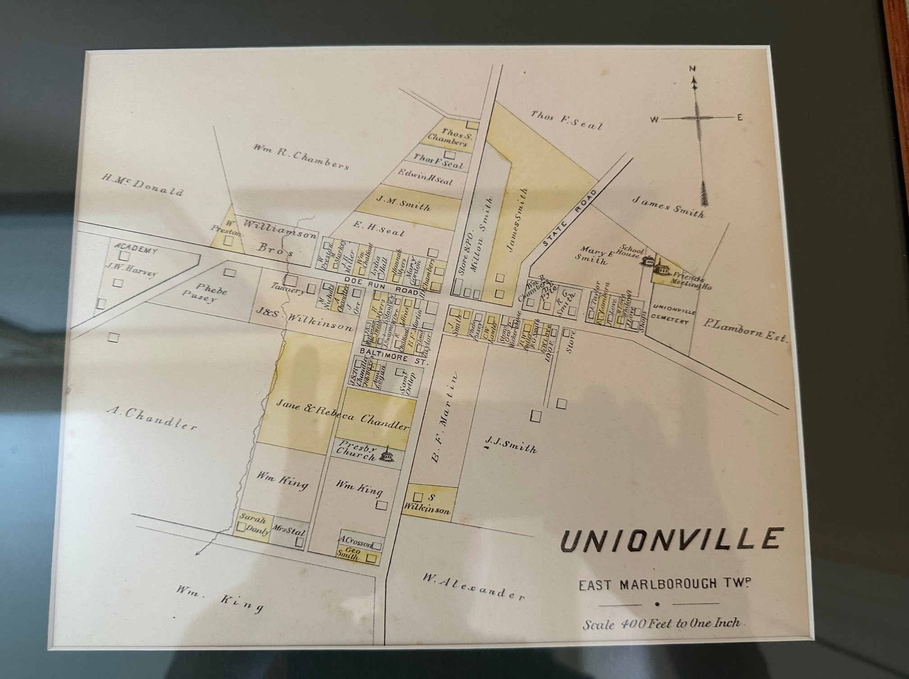
1883 Breous Official Series of Farm Maps Chester County Pennsylvania published by W. H. Kirk & Co. Philadelphia. Unionville. Portion of Plate 122.

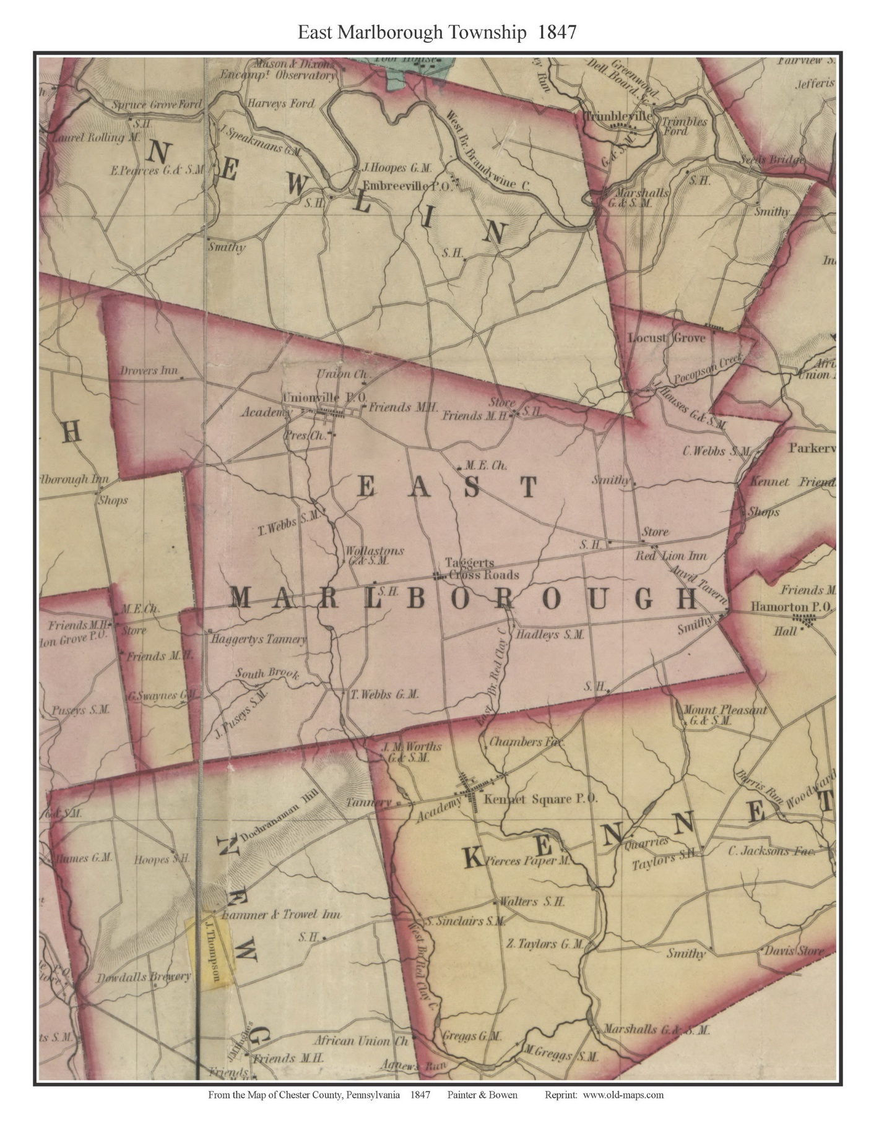From Map of Chester County, Pennsylvania by Painter and Bowen, 1847.

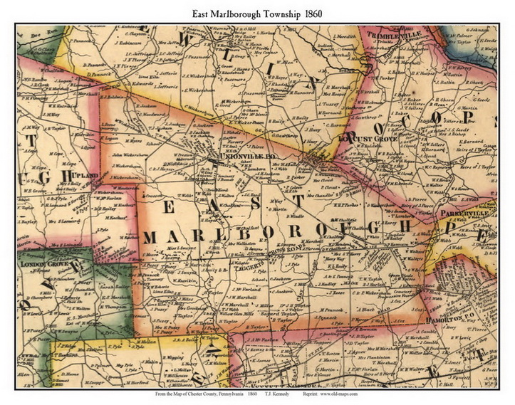
From Map of Chester County, Pennsylvania by T.J. Kennedy, 1860.

